Sam Rhine - Genetic Update Conferences - www.samrhine.com
Follow Sam’s Updates on Twitter: @samrhineguc

Genes and Cancer…..Oncogenes and Tumor Suppressor Genes
Cancer Therapy…..and Cancer Stem Cells

References: 1. Check out Sam’s Previews at: http://samrhine.com/previews/
2. Outlook Cancer Supplement, Nature, Vol. 509, pp. S50-S90, May 29, 2014
also in Scientific American, Supplement, July 2014, pp. S1- S35
3. Breast Cancer - Science (Cover Article), Vol. 343, pp. 1451-1475, March 28, 2014
4. Cancer Stem Cells - Cell Stem Cell, Vol. 14, No 3, pp.275-321, March 6, 2014
5. Cancer Immunotherapy…..‘Breakthrough of the Year’,
Science, Vol. 342, pp. 1431-1443, December 20, 2013
6. Web Site: http://www.biooncology.com/

“all Cancer is Genetic…..but most Cancer is not Inherited”

I. Genes and Cancer…..

A. U.S. Human Cancer Statistics for 2014-15:

-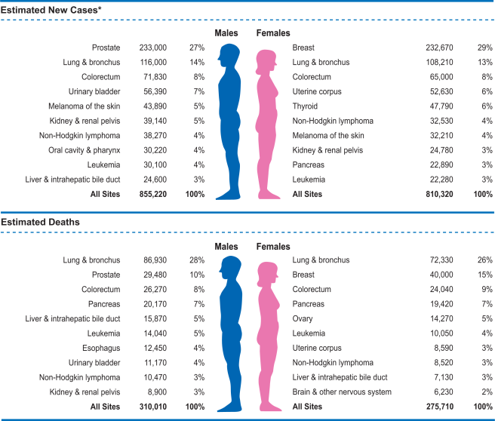

CA: A Cancer Journal for Clinicians, Vol. 64, Is. 1, pp. 9–29, Jan/Feb 2014

B. Basic Cancer Concepts:

1. Mitosis and Apoptosis

a. Mitosis - programmed cell birth - one cell divides to become two
prophase / metaphase / anaphase / telophase

i. Symmetric Mitosis - for cell expansion - increase the number of cells
symmetric illustration

ii. Asymmetric Mitosis - for cellular differentiation in the embryo
asymmetric illustration

one cell is retained as the dividing cell - ‘Self Renewal’
one cell go on a differentiation pathway - ‘Differentiates’
common type of mitosis found in stem cells

iii. in the old days…..”all cancer was the result of too much mitosis”

b. Apoptosis - programmed cell death - eliminates unneeded, dying or
damaged cells - discover in the 1970s

i. shrinkage / blebbing / fragmentation (apoptotic bodies) / engulfment

ii. ‘Programmed Cell Death’ / ‘Cellular Suicide’ / ‘Blebbing to Oblivion’
a neat, clean, tidy…..no muss, no fuss…..way to get rid of a cell

c. Mitosis and Apoptosis -
i. cellular equilibrium…..cellular homeostasis maintains the normal
number of cells in the body
ii. if the equilibrium is upset…..inappropriate accumulation of cells
Too Much Mitosis - tumor…..Mitosis out of control
Not Enough Apoptosis - tumor…..Apoptosis out of control

d. Chemotherapy kills cancer cells….. via Apoptosis

2. All cancer (all tumors) originate from one single somatic cell

a. one single somatic cell is converted into a single cancer cell
b. the conversion is due to DNA Damage in the original normal cell
c. that first single cancer cell is the ‘Founder Cell’ - the Founder of the Tumor
d. the conversion of a normal cell into Founder Cell is ‘Transformation’
e. from the Founder Cell - the cancer, the entire tumor, will develop
f. Founder Cell = 1 cell out of 80,000,000,000,000 - leads to the tumor!

3. Genome Stability - we want the genome to be Stable - No Changes
Changes = the DNA Damage that causes Transformation

a. GENE MUTATIONS - about 400 genes can mutate to cause cancer

i. ONCOGENES (ONC) - usually turned OFF

cause Cancer when mistakenly turned ON
the gene mutation mistakenly turns them ON
‘Activation Mutation’ - Activates gene by mistake
acts as Dominant Genes - need only one of the two genes mutated
…..~80% of the 400 cancer causing genes / 3 letter nickname

SRC SaRComa
RAS RAt Sarcoma
SIS SImian Sarcoma
ERB ERythroBlastosis
MYC MYeloCytosis
ABL ABelson Leukemia virus
BCL2 B-Cell Lymphoma-2

ii. TUMOR SUPPRESSOR GENES (TSG) - usually turned ON

cause Cancer when they are mistakenly turned OFF
the gene mutation mistakenly turns them OFF
‘Inactivation Mutation’ - Inactivates gene by mistake
acts as Recessive Genes - need both of the two genes mutated
…..~20% of the 400 cancer causing mutations - nickname

BRCA1 BReast CAncer #1
BRCA2 BReast CAncer #2
RB RetinoBlastoma
APC Adenomatous Polyposis Coli
DCC Deleted in Colon Cancer
P53 Protein 53

iii. ONCOmirs - microRNAs from Non-Coding Genes - turn genes ‘ON’

iv. All somatic cells accumulate cellular mutations over time

Driver Mutations - drive the cancer - ONCs and TSGs
cell growth advantage / invasiveness / metastasis

Passenger Mutations - no cancer effect / ‘along for the ride’

v. Cancer Causing Mutations may be Exogenous or Endogenous

Exogenous Mutations - Due to Factors Outside the Body
Carcinogen Exposure…..Carcinogens = Cancer Causing Agents
Most Carcinogens are Mutagens…..they cause mutations!

Environmental or Life Style Exposures Examples:

Cigarette Smoke - over 55 Carcinogens > Lung Cancer
PAH - Polycyclic Aromatic Hydrocarbons
Nicotine-Derived Nitrosoamines
Primary - Secondary - Tertiary Smoke Exposure
Ultra Violet Light > Skin Cancer
Ionizing Radiation - X-rays & Gamma Rays
Asbestos > Mesothelioma
Virus > Liver Cancer - Hepatitis B
Cervical Cancer - Human Papilloma Virus
Bacteria > Stomach Cancer - Helicobater pylori
Lead > Lung Cancer
* Over 200 Exogenous Carcinogens Known!* http://www.cancer.org/cancer/cancercauses/othercarcinogens/generalinformationaboutcarcinogens/
known-and-probable-human-carcinogens

vi. Endogenous Mutations - Due to Factors Inside the Body - inside a cell

DNA replication errors at S Phase before mitosis

S-Phase Repair or MisMatch Repair:

DNA Replication during S Phase - Replication enzyme is DNA Polymerase
DNA Polymerase always makes some mistakes: 1 / 1,000,000 nucleotides
Human Genome contains > 3,000,000,000 nucleotides (x2 both sides)
6,000 replications errors / per cell / per mitosis

Replication Errors can result in Mutations - Endogenous

Interphase Repair:

DNA mutations in skin cells due to UV exposure - somatic cell mutation.
Interphase Repair Enzymes fix the damage and correct the mutations
However, if the Repair Enzymes fail to correct the damage, or
if there are excessive mutations - too many to repair…..

Results in Endogenous Mutations

b. CHROMOSOME ABNORMALITIES

i. Translocations - two chromosomes break and rejoin

exchange parts of between two chromosome arms
often equal exchanges - reciprocal translocation
an oncogene can be is activated at the break point
leading cause of leukemias and lymphomas

ii. Aneuploidy - due to mitotic nondisjunction - add or lose chromosomes
extra chromosomes - extra copies of ONCs
missing chromosome - lose copies of TSGs

ii. Insertions or Deletions
Insertions - can ramp up an ONC = turn it ON
Amplifications - ramp up an ONC
Deletions - can cause loss of a TSG = turn it OFF

c. CHROMOTHRYPSIS - Chromosomes Pulverized into Small Fragments

i. multiple chromosomes break and rejoin at multiple positions

ii. some chromosome fragments are lost in the process

iii. rejoining can lead to ONC Activation and / or TSG Inactivation

iv. may be an atavistic mechanism - normal process in ciliated Oxytricia

d. EPIGENETIC CHROMATIN ERRORS - Opens and / or Closes Chromatin

i. HyperMethylation - Closes - genes OFF - can Inactivate a TSG

ii. HypoMethylation - Opens - genes ON - can Activate an ONC

4. All Cancer is Genetic…..but Most Cancer is not Inherited

Remember: the terms Genetic and Inherited are not the same

a. Inherited - runs through the family, passes from parent to child

passes through the egg and sperm from parent to child

often occurs in the family in consecutive generations

most cancer NOT inherited - just crops up…..95%

95% of cancer is SPORADIC
b. Most cancer…..95%: We inherit, from our parents perfectly NORMAL
DNA in our genes and chromosomes

Then: some time during our life time…..

i. NORMAL GENE MUTATES - DRIVER MUTATION
an ONC or TSG > somatic cell mutation = ‘FOUNDER’

ii. CHROMOSOME TRANSLOCATION occurs, activates
an ONC > somatic cell translocation = ‘FOUNDER’

iii. CHROMOTHRIPSIS occurs - activates ONCs or inactivates
TSGs > chromothriptic somatic cell = ‘FOUNDER’

iv. EPIGENETIC CHROMATIN ERROR occurs - ONC or TSG
leads to somatic cell with epigenetic error = ‘FOUNDER’

Most DNA Damage that leads to cancer - occurs during our lifetimes!

c. About 5% of Cancer…..there is an inherited factor
INHERITED PREDISPOSITION
…..increased chance…..increased tendency
occurs with the TSGs…..BRCA1 / RB / APC

i. inherit one (of the two copies) with a germ line mutation
mutation is passed through the egg or sperm
passing through the family = inherited

d. Breast Cancer - women in US - 1 in 8 will develop breast cancer = 12%

i. 95% - Sporadic (usually late age of onset)

ii. 5% - Inherited Predisposition (often earlier age of onset)

If a WOMAN inherits one (of the two) BRCA genes with an
inactivating TSG driver mutation…..

Breast Cancer risk goes from 12% to 80% and…..
Ovarian Cancer risk goes to 50%

If a MAN inherits one (of the two) BRCA genes with an
inactivating TSG driver mutation…..
increased chance for pancreatic, prostate and male breast Ca

5. How do Most Tumors Develop?

a. Founder Cell gives rise to the Primary Tumor - 8 to 10 years
Few cancer deaths are caused by the primary tumor.
Most cancer deaths due to Metastasis…..Spreading thru body

b. Metastasis - migration of cancer cells from the Primary Tumor into
other remote body tissues…..where they can ‘seed’ and establish
Secondary Tumors! Most cancer deaths from secondary tumors!

c. Example: Primary Tumor develops in the breast where it is localized
at the site where it originated. But as the tumor continues to
develop it accumulates new mutations and becomes ‘Invasive’…..
invading areas of the tissue beyond the limits of the original tumor.

The invasive cells may gain entry into a blood vessel and then
travel all through the body via the circulatory system…..
or it may gain entry into lymphatic vessel and then travel all through
the body via the lymphatic system.

The cancer cells can then exit from the blood vessel or lymphatic
Vessel and some distant tight and ‘seed’ secondary tumors in the
bone, lung, liver, colon etc.
Most cancer deaths from secondary tumors!

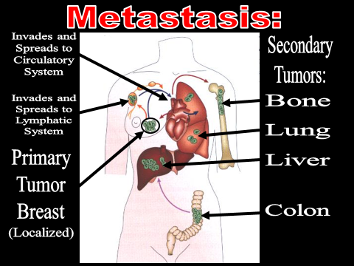
d. Epithelium and EMT

i. Epithelial Cells form a covering or act as a lining in the body
ii. sits upon a basement membrane - laminar matrix
iii. below the basement membrane is the connective tissue with:
blood vessels, lymphatic vessels and nerves
iv. epithelial cells with cell to cell adhesion and rigidity = little box
BUT…..epithelial cells can lose their rigidity and convert into
migratory cells – Mesenchymal Stem Cells - which can move
throughout the body - EMT: Epithelial to Mesenchymal Transition
Cells convert to a cell that can be Invasive and Metastasize

e. Step by Step of Tumor Formation

i. One epithelial cell acquires a mutation - ONC or TSG
that single cell (orange cell) is the ‘Founder Cell’
it can grow faster than the other normal cells
Leads to a ‘Clone of the Founder Cell’ = ‘Clonal Expansion’
Let’s check back at the same site…..four years later.

ii. Four years since the origin…..
See an accumulation of orange clone = ‘Hyperplasia’
One orange cell acquires a second mutation (pink)
Pink cells can grow faster than the orange cells
Second clonal expansion of pink cells = Two clones in the tumor
Let’s check back at the same site…..four years later.

iii. Eight years since the origin…..
See an accumulation of pink and orange clones = Dysplasia
One of the pink cells acquires a third mutation (lavender)
Lavender cells grow faster than the pink cells
Third clonal expansion of lavender cells = Three clones in tumor
Let’s check back at the same site…..four years later.

iv. Twelve years since the origin…..
Primary tumor - still localized - cancer in situ…..three clones
One of the lavender cells acquires a fourth mutation (blue)
Blue cells go through the EMT conversion - becomes invasive
penetrates through the basement membrane and invades the
underlying connective tissue - ‘Invasive Tumor’ - four clones!
Let’s check back at the same site…..four years later.

v. 16 years since the origin…..
One of the blue cells acquires a fifth mutation which
Permits the cell to break away from the tumor mass and enter
a blood vessel - beginning of Metastasis - five clones
Let’s check back at the same site…..four years later.

vi. 20 years since the origin…..
5 mutations - 5 clonal expansions
Invasive, Metastasizing, Life Threatening Carcinoma
Carcinoma is a tumor that originates from an epithelial cell
Tremendous Tumor Heterogeneity

6. Tumor Heterogeneity - Complexity of a Tumor

a. All the combinations of over 400 mutated ONCs and TSGs
Drivers and Passengers
b. Plus chromosomes: Translocations / Aneuploidies / InDels
c. Plus Chromothripsis
d. Plus Epigenetic Chromatin Errors
e. Complexity of Diagnosis and Therapy
Mixture of Expanded Clones
some with MET and others with EMT cell reversion
Mixture of Therapeutic Targets
f. TCGA - The Cancer Genome Atlas
Lung Adenocarcinoma - leading cause of cancer death
in the world…..>1,000,000 per year
Cancer Cell Mutations: Drivers + Passengers = 8.9 / 1,000,000
Normal Cell Mutations: Passengers = 1 / 30,000,000
Cancer Cells: 265 fold increase!
18 Different Drivers - Significantly Mutated
EGFR in females / RBM10 in males
New System for Cancer Classification:
Molecular vs. Histopathologic (microscopic)
Nature, vol. 511, pp.543-548, July 31, 2014
Multiplatform Analysis of 12 Cancer Types Reveals Molecular
Classification within and across Tissues of Origin

Cancers are more likely to be genetically similar based upon
their cell type of origin rather than their organ of origin

About 10% of cancers today, would be improperly classified
with the new system…..diagnosis…..therapy…..prognosis

g. Example of Tumor Formation - Colorectal Cancer

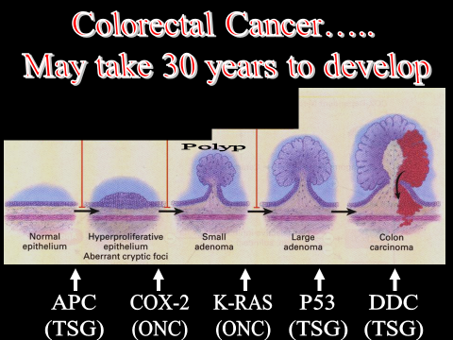
7. How do Oncogenes and Tumor Suppressor Genes Cause Cancer?
a. What is a tumor - inappropriate accumulation of cells!
What causes - inappropriate accumulation of cells?
- inappropriate mitosis - mitosis at the wrong time

b. Cell Cycle - Life Cycle of a Cell
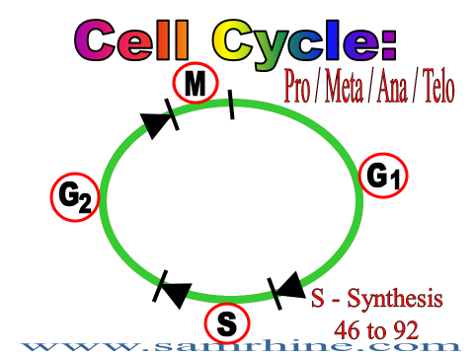

i. G1 - Gap in time between the last mitosis before S
S - Synthesis of DNA - go from 46to 92 chromosomes
G2 - Gap in time between S and Mitosis
M - Mitosis: Prophase / Metaphase / Anaphase / Telophase

ii. Cycle is usually turned off - only turns on for mitosis

iii. What keeps the cycle turned off? Protein Padlock

iv. Two Big Questions: What turns the cycle ON?
What unlocks the Padlock?

What turns the cycle OFF?
What is the Protein Padlock?

c. What turns the cycle ON? What unlocks the Padlock?

1. SET of NORMAL GENES…..which produce a
2. SET of NORMAL ‘INACTIVE’ PROTEINS
3. SET of PROTEINS when ‘ACTIVATED’
produce a CELL SIGNAL PATHWAY
4. CELL SIGNAL PATHWAY - TURNS CYCLE ‘ON’

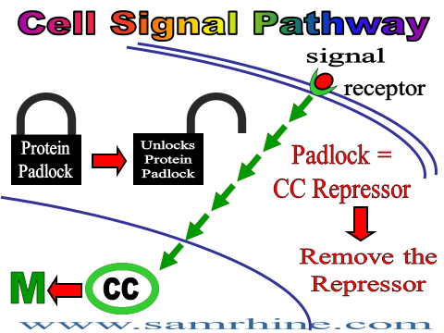

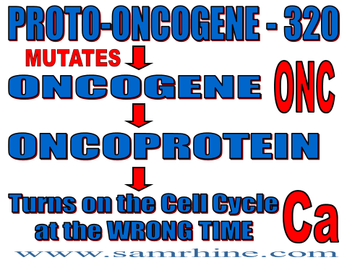
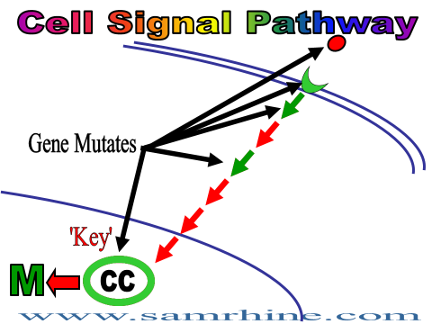
d. Cell Cycle Jargon…..
CELL SIGNAL PATHWAY
PROTEIN ACTIVATION RELAY
CELL SIGNAL TRANSDUCTION SYSTEM
SECOND MESSENGER SYSTEM

e. Normal Genes, ~400, can mutate to cause cancer
i. Oncogenes - ONC:
Dominant Trait - One Allele Mutates
ii. Tumor Suppressor Genes – TSG
Recessive Trait - Both Alleles Mutated
TSG mutation = HIT

f. TSG - Tumor Suppressor Genes…..
INHERITED PREDISPOSITION
i. Retinoblastoma (RB) - cancer of the retina of the eye RB Gene at 13q14.2 - produces the RB Protein
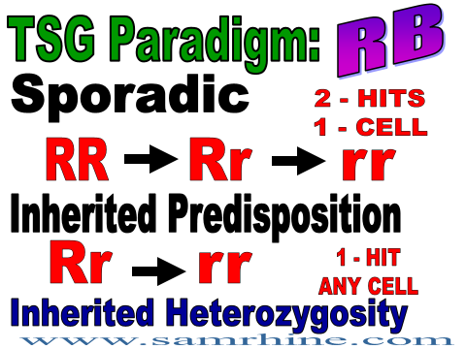
g. What does the RB Protein do?
Cell Cycle Repressor…..RB Protein is the PADLOCK
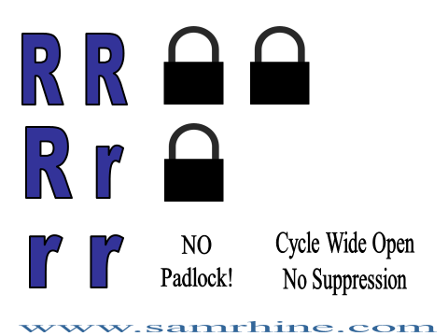

h. ONC = ONCOGENES - summary

There are normal genes that produce normal ‘inactive’
proteins, which are part of the Cell Signal Pathway

Under normal conditions those proteins are ‘activated’ only
during normal mitosis at M of the cell cycle

BUT: If those normal genes mutate, the mutation can cause
the production of abnormal ‘activated’ protein which
can cause the pathway to send a mitosis signal at the
wrong time = inappropriate mitosis = cancer

i. TSG = TUMOR SUPPRESSOR GENES - summary

Normally the cell cycle is OFF, and it is locked OFF by
certain normal genes that produce normal proteins that
act as a cell cycle padlock

BUT if the those genes mutate, and the proteins are no longer
produced, then the PADLOCK is missing and the cycle is
no longer locked ‘OFF’ which leaves the cycle ‘ON’.

8. Cancer Stem Cells

a. ‘STEMNESS’ - the unique characteristics of stem cells

i. Self Renewal - with asymmetric mitosis mechanism
cell proliferation
ii. Differentiation - with asymmetric mitosis mechanism
produce any of 220 human cell types
iii. Migration - EMT transition
migrate throughout the body
iv. Protection from DNA Damage
pump / purge harmful chemicals and repair ‘lethal’ damage

b. What if the Founder Cell…..is a Stem Cell?

CANCER STEM CELL - Founder Cell with ‘Stemness’

i. Self Renewal - Tumor Cell Proliferation
Drives Tumor Growth
ii. Differentiation - Produce all the tumor cell clones
Drives Tumor Clone Development
iii. Migration - Migrate throughout the body
Drives Tumor Metastasis
iv, Protection from DNA Damage - Resist chemo & radiation
Drives Tumor Recurrence

c. Many Cancer Therapies…..Chemotherapy and Radiation…..

i. Destroy the bulk of the tumor cell clones…..so the tumor shrinks
and sometimes disappears
ii. But may ultimately fails because they do not kill that small
population of Cancer Stem Cells - leading to recurrence!
iii. Future: Combinational Therapy
Chemotherapy or Radiation to destroy the bulk of the tumor
cell clones…..
Combined with separate drugs that will selectively destroy
the Cancer Stem Cells
iv. Examples:
GBM - GlioBlastoma Multiforme brain tumor - primary tumor
resistant to Radiation Therapy
AML - Acute Myeloid Leukemia
most common acute leukemia in adults

d. CD-47 - (Cluster of Differentiation 47)

i. CD-47 is a molecule found on the surface of many human cells

ii. it instructs circulating macrophages not to destroy those cells

CD-47 is the “Don’t Eat Me” signal

iii. the body uses CD-47 protein on the cell surface to protect cells
from being destroyed when the cells are young
but diminishes when the cells get older and need to be replaced
new RBCs have lots of CD-47 when first produced
but CD-47 is lost as they get older > macrophage destruction

iv. HOWEVER…..
most cancer cells have large amounts of CD-47 on surface

the CD-47 protects the cancer cells from being destroyed by
the macrophages of the immune system…..
the ‘Don’t Eat Me’ signal protects the cancer cells from
natural, normal, immune destruction

e. Anti CD-47 Therapy for AML (Acute Myeloid Leukemia) in mice

i. the AML Leukemia Stem Cell (LSC) is covered with CD-47

ii. Protecting the LSC from macrophage immune destruction

iii. Monoclonal Antibody against CD-47 (B6-H12)
…..masked the CD-47 on cancer cells - AML disappeared
iv. CD-47 is found in large amounts on the surface of nearly every
type of Human Cancer Stem Cell.

v. Human CD-47 human trials began on August 15, 2014 for
human ovarian, breast, colorectal, pancreatic and brain Ca

Stanford University trials: http://stemcell.stanford.edu/CD47/

f. Human Embryology
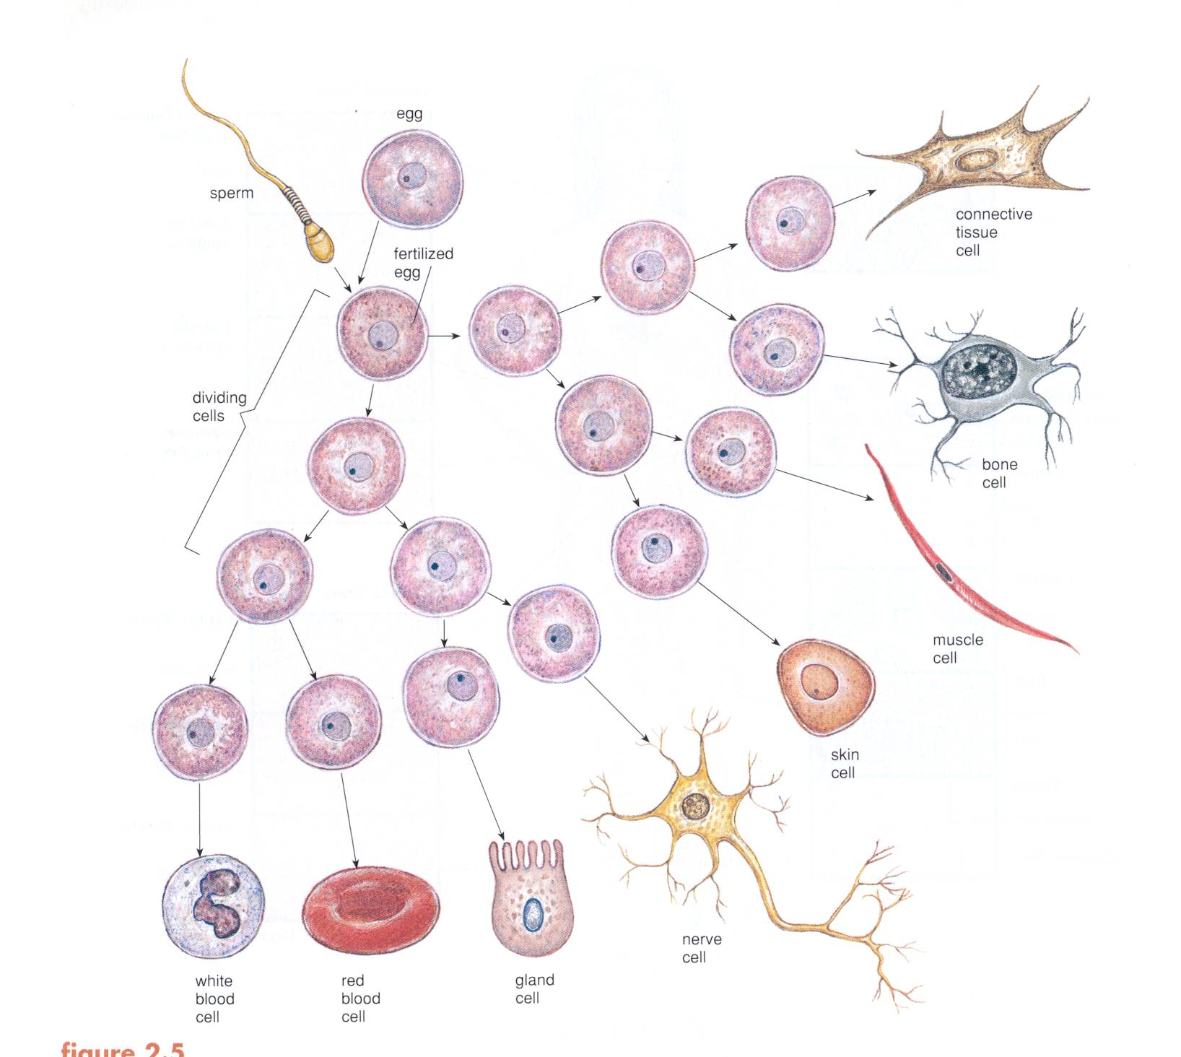

i. 220 specialized human somatic cells develop from the zygote

by way of 220 one way streets / 220 sets of signals
to form 220 terminally differentiated somatic cells

i.. as DIFFERENTIATION PROGRESSES…..

SELFRENEWAL REGRESSES

Trade off: Gain Specialization but lose Mitotic ability
220 terminally differentiated cells cannot divide
Cannot become a FOUNDER!

Where do you find mitosis in the human body cells? Stem Cells!

All FOUNDERS…..all CANCER…..come from STEM CELLS

g. Future Possibility…..

Screening for new cancer stem cells with CD-74
Begin CD-47 antibody therapy very early - knock out the CSCs!
STOP CANCER BEFORE IT BEGINS!!

9. Cancer Therapy - the ‘DREAM’…..Magic Bullet!
Magic Bullet Therapy: attacks only the cancer cells and
does not harm any normal somatic cells

a. Tumor removal before metastasis:
polyp lasso / skin cancer resection / surgery
b. Organ removal before any cancer occurs: mastectomy and or
oophorectomy with a BRCA1 mutation carrier
b. Chemotherapy: harsh cytotoxic chemicals that can cause the
death of rapidly dividing cancer calls via apoptosis
c. Radiation: direct radiation at rapidly growing cancer cells
leading to chromosome damage and cell death
d. Bone Marrow Transplant: destroy the WBC with leukemia
replace them with new normal WBC - self or donor
e. Targeted Therapies: Gleevec - focus to correct the BCR/ABL
oncoprotein in Chronic Myelocytic Leukemia f. Immunotherapy - induce the immune system, T-Cells, to
attack and destroy the tumor
g. Hormonal Therapy - some breast and prostate tumors can be
affected by adding or removing certain hormones
like estrogen or testosterone
h. Angiogenesis Inhibitors - all tumors need their own blood
supply to survive, these therapies stop the formation of
new blood vessels in a developing tumor;
i. Antibody Blocking: block signal pathway receptor - Herceptin
blocks the HER/new receptor so the oncoprotein
signal cannot initiate the abnormal mitosis signal
j. micro RNA: man-made microRNA molecule can selectively
turn of one specific oncogene - prostate cancer
k. Vaccines - for cancer caused by Oncoviruses like Hepatisis
for liver cancer and HPV for cervical cancer
k. Therapeutic Cancer Vaccines - use cancer cell proteins to
stimulate the immune system to attack the cancer
l. Liquid Biopsy - nearly every tumor sheds DNA into the blood
new tests are coming to diagnosis any cancer from a
simple, annual, blood evaluation.
m. Epigenetic Therapy - Demethylation of Chromatin for ONC

…..Please get Cancer Screening Exams!!
10. Cancer Jargon

Neoplasia - ‘New Formation’, very general term, a rapidly growing abnormal tissue
Neoplasia > Neoplasm > Tumor
Tumor - abnormal mass of cells, growing more rapidly than normal…..
inappropriate accumulation of cells
Founder Cell - the original, single, mutated cell that will transform and develop into
the tumor
Transformation - the conversion of a normal somatic cell into a mutated cancer cell
with malignant potential due to some type of DNA damage
Clone - group of genetically identical cancer cells derived from one mutated cell

Clonal Expansion - the development of a mass of mutated cells in a tumor clone

Primary Tumor - localized and benign, cancer in situ, often the first stage where
the developing tumor is recognizable.
Metastasis - spreading of cancer cells from the primary tumor to other remote areas
of the body through the blood stream or lymphatic system where the cells
can ‘Seed’ the formation of secondary tumors.
Secondary Tumor - tumors that develop at various sites around the body after being
distributed and ‘Seeded’ by metastasizing cells form a primary tumor.
Benign - a tumor which is localized at the site where it originated, it has not spread
has not metastasized…..’Safe’
Malignant - tumor characterized by uncontrollable growth, invasiveness and
Metastasis - “Life Threatening”!
Cancer - Various types of malignant neoplasms, most of which are invasive and
Metastasize
Solid Tumor - cancer cells packed and growing together in a unified mass

Dispersed Tumor - cancer cells proliferating individually - not packed together
Leukemias and Lymphomas

Acute - cancer with a relative short time course, sometimes only months from
diagnosis to death
Chronic - cancer with a relatively long time course, may be many years from
diagnosis to death
Oncology - the study of the causation, pathogenesis and treatment of cancer

Carcinoma - cancer where the Founder Cell was an epithelial cell

Sarcoma - cancer where the Founder Cell was a connective tissue cell

Leukemia - cancer where the Founder Cell was a Leukocyte = white blood cell

Lymphoma - cancer where the Founder Cell was a Lymphocyte = white blood cell

Melanoma - cancer where the Founder Cell was a melanocyte = pigmented skin cell

II. Regenerative Medicine…..Tissue Engineering
Producing Replacement Human Tissues
and Organs in the Laboratory….'Neo-Organs'

A. U.S. Organ Transplant Statistics for 2014-15:

1. Why? >122,000 persons in US - waiting for an organ transplant!

a. < 30,000 will receive a transplant - > 92,000 die while waiting
heart, lung, liver, kidney, pancreas etc. - too few donors!
b. average person on liver waiting list…..waits 26 months!
c. average person on lung waiting list…..waits 3 years!
~50% of those over 50, waiting for kidney, will die while waiting!

2. Regenerative Medicine:
inducing human tissues that are damaged, worn out or missing…..
to regenerate and return to their normal state
persuading the body to heal itself through the delivery, to the
appropriate site, of cells, biomolecules and / or supporting structures

3. Tissue Engineering: production of human tissues and / or organs in
the laboratory, and their subsequent transfer back into the body, to
compensate for an organ / tissue that is missing or not functioning
normally

B. Basic Organ Transplant Concepts:

1. Tissue and Organ Sourcing…..
Sources of cells for transplantation and regenerative medicine:

a. Histocompatability and Rejection: HLA System
Human Leukocyte (WBC) Antigens

b. What causes rejection? Immune System: Discriminates between
'Self' and 'Non-Self' - protects self / destroys non-self
Immune attack orchestrated by the T lymphocytes = WBC
attack and destroy Non Self (foreign) tissues

i. Autograft (Autologous)
Auto = self - use your own tissue - no rejection

ii. Isograft (Isologous)
Iso = equal - use tissue of identical twin - no rejection
First Kidney Transplant - December 23, 1954
Dr. Joseph Murray - Harvard Medical School
Nobel Prize in Medicine - 1990
Herrick Twins - Ronald / Donor & Richard / Recipient

iii. Allograft (Allogenic)
Allo = Different - use tissue from a different person
> Rejection - usually need immunosuppressive drugs

iv. Xenograft (Xenologous)
Xeno = foreign - use tissue from a different species
pig valve into a human heart

v. Biocompatible material - inert = not rejected
plastic, titanium, aluminum, ceramic

c. Host v. Graft - most medical rejections
Host (Patient) rejects the Transplant (Graft)

d. Graft v. Host - some medical rejections
Transplant (Graft) rejects the Host (Patient)

GVHD - Graft Versus Host Disease
Bone Marrow (BM) transplants / Face transplants
Large number of WBC in Bone Marrow / Face

2. Donor Cell or Tissue Sources:

a. Adult Somatic Cells and Tissues

b. Embryonic Stem Cell derivatives

c. Adult Stem Cell derivatives

d.. iPS - induced Pluripotent Stem derivatives
Stem Cells made from skin - no embryos used

3. SCAFFOLD - Framework for the engineered tissue or organ

Synthetic: Biocompatible / Biodegradable Materials
Polymers: PGA: PolyGlycolic Acid
Ceramics
Natural: Collagen

C. Tissue Engineering Examples:

a. HSE - Human Skin Equivalent

i. Scaffold = bovine type I collagen
+ Epidermis = keratinocytes + Dermis = fibroblasts

ii. Primary Use - skin grafts in burn victims
bed sores / diabetic skin ulcers
EB - Epidermolysis Ballosa MIM = #2267000
Genetically Engineered Skin - Tissue Engineering +
Genetic Engineering
Skin Cell Donors - newborn baby BOYS…..
one donation > cover 6 football fields
iii. Skin Cell Gun - Spray-on Skin http://en.wikipedia.org/wiki/Skin_cell_gun

b. Urinary Bladder - often too small - due to neural tube defect

i. Urinary Bladder - inner Uroepithelium / outer Smooth Muscle

ii. Biopsy existing bladder cells for new bladder = autologous
Separate biopsied Epithelial cells from Muscle Cells
Expand (increase number ) both cell types in vitro via mitosis
Transfer to Biocompatible Biodegradable Scaffold - PGA
From biopsy to surgical insertion = 7 - 8 weeks! Bladder Ca

c. Nose - Beck Weathers - from severe frost bite
PGA scaffold - looks like styrofoam
seeded inside and out with patient's own cells = autologous

d. Ear - Treacher-Collins Syndrome
Scaffold: Biocompatible BUT NOT Biodegradable
Initially Grown in petri dish…..then transferred to under the
skin of a mouse for completion

e. Chin / Jaw - facial cancer
titanium mesh cage scaffold + bone mineral blocks + BM mix
+ recombinant BMP-7 - grown initially in latissimus dorsi

f. Finger - porous ceramic scaffold
seeded with patients cells = autologous

g. Arteries / Veins - flat sheet and then rolled into a tube - like pasta

h. Corneal Epithelium - grow new cornea epithelium cell layer within a
plastic boundary ring – takes ~21 days
biopsy cornea epithelium limbus stem cells from periphery of the
eye – ‘seeded’ into the plastic ring
or biopsy oral epithelium to make new cornea
transfer with no suture - 35 minutes with local anesthesia

i. Teeth - grow an organ in a test tube

j. Encapsulated Cell Therapy for Type 1 Diabetes
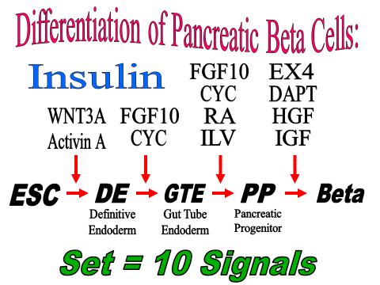
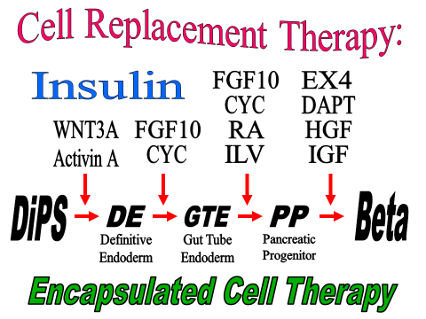
First Human Trials - implant capsules under the skin!
http://www.sciencedaily.com/releases/2014/09/140910093052.htm

Encapsulated Cell Therapy - capsule the size of a pencil lead
Retinitis Pigmentosa / Huntington Disease / Parkinson Disease
capsule contains cells producing therapeutic protein
therapeutic protein exits through pores in the capsule,
BUT immune cells (WBCs) cannot enter to initiate rejection
k. Ligaments / Tendons - Orb Weaver spider web protein
strongest biological molecule
produced by transgenic goats or E. coli

l. Sutures - covered with autologous cells / can be genetically engineered

Petroleum Jelly - 'Vaseline' Gene Therapy - for external use on skin

m. Kidney - First Man-Made - 'Organoid' - 2004 - from bovine ESCs

Artificial human kidney lined with human renal cells

n. Liver - Liver Cell Jet Printer
inject liquid polymer into liver vasculature
digest away all the liver cells
leaving 3-D pattern of normal liver vasculature
vasculature pattern is programmed into computer
program makes layers of scaffold with holes for blood vessels
'Printer' distributes liver cells across the scaffold layers
layers are then tiered back together > Liver in vitro

o. Heart - Mechanical heart to keep heart transplant patient alive until
a donor heart becomes available

Heart - Natural / normal heart scaffold exists within every heart
Decelluarization - Detergent Perfusion
Yields normal heart Scaffold
Recellularization

p. Rat Lung - Decellularize / Recelluarized lung cells from murine ESCs

q. Mouse Liver - Decellularization and Recellularization

r. Human Kidney - human cells recelluarize a pig kidney scaffold
success in the rat - April 2013

s. Rat Kidney success – decelluarize / recelluarize - May 2013

t. Trachea - damage from tuberculosis - stripped and reseeded with
MSCs from Bone Marrow

u. Heart Valve - anomaly diagnosed in unborn baby
amniocentesis to obtain MSCs used to construct
new heart valve before birth - surgical replace old valve

v. Osteogenesis Imperfecta (OI) - very fragile bones prone to multiple
fractures - diagnosed in utero via amniocentesis
mothers MSCs injected into the umbilical cord before birth
via chordocentesis - OI corrected

w. Finger Regeneration - use powder from dessicated bladder of a pig
grew back in 4 weeks
http://www.cbsnews.com/video/watch/?id=3805459n

x. MaSC - Adult Mammary Stem Cell
regenerate murine mammary gland from one stem cell

PSC - Prostate Stem Cell
regenerate murine adult prostate from one stem cell

y. Mouse / Rat Embryo Chimeras - Blastocyst Complementation Test
in vivo Organogenesis

Produce an organ of one species from the developing embryo of
another species

Produce a rat pancreas in a developing embryo of a mouse

Place rat (blue) iPSCs in the blastocyst of a genetically modified,
pancreatic deficient, mouse embryo - and the mouse embryo
produces a rat pancreas

This can be made to work between any two mammals…..
and human are mammals

Future therapy for human Type I diabetes…..?
Begin with human Diabetic iPS = DiPS, Place human DiPSs in the
blastocyst of a genetically modified, pancreatic deficient
pig embryo - the pig embryo would makes a human pancreas
transplantable into the human DiPS donor

Updated - September 26, 2014

